**UNIVERSITY OF TECHNOLOGY, MAURITIUS**

**SCHOOL OF INNOVATIVE TECHNOLOGIES AND ENGINEERING**

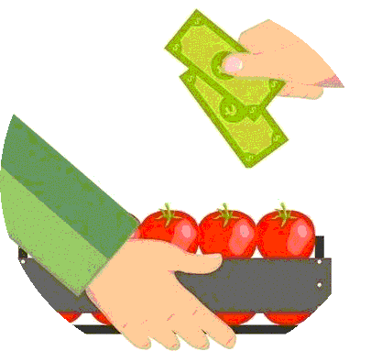

**FOOD PRICE ANDROID MOBILE APPLICATION**

**By**

**ECHONGA TOBBY 151209**

**This dissertation is submitted in partial fulfilment of the requirements for**

**the degree of Bachelor of Science with Honours in Software Engineering /**

**Business Information Systems / Web Technologies / Computing and**

**Information Systems**

**AUGUST 2017**

**Abstract**

This project is aimed at developing a Mobile Application for farmers. This is a mobile application where both the sellers and the buyers can interact with each other and without any middlemen.

The project has been planned to be having the view of distributed architecture, with centralized storage of the database. The application for the storage of the data has been planned. Using the constructs of Oracle 10g and all the user interfaces have been designed using the JAVA. The database connectivity is planned to use the “Database” methodology. The standards of security and data protective mechanism have been given a big choice for proper usage. The application takes care of different modules and their associated reports, which are produced as per the applicable strategies and standards that are put forwarded by the administrative staff.

**Acknowledgment**

I would like to thank God for giving me the wisdom, knowledge and understanding to work on my project.

I wish thank my project supervisor **Mr. Kanaksabee Pillay** for whose support in terms of technical advice and guidance helped to me a lot in bringing this project to this level.

Special thanks goes to my parents **Quinto** and **Dorothy Rwotoyera** for all the love support to achieve my goals.

I would also like to thank all my lectures, teachers throughout my life especially **Mr Magezi** for giving me confidence in myself.

Lastly but not least, I thank the **Government of the Republic of Mauritius** for the financial support throughout my 3 years’ course of BSc (Hons) Software Engineering.

**List of Tables**

*Table 1……………………………………………………………………………………………………………………………………………………8*

*Table 2.1……………………………………………………………………………………………………………………………………………………10*

*Table 2.2……………………………………………………………………………………………………………………………………………………11*

*Table 3.1……………………………………………………………………………………………………………………………………………………16*

*Table 4.1……………………………………………………………………………………………………………………………………………………19*

*Table 4.2……………………………………………………………………………………………………………………………………………………19*

*Table 4.3……………………………………………………………………………………………………………………………………………………19*

*Table 4.4……………………………………………………………………………………………………………………………………………………20*

*Table 4.5……………………………………………………………………………………………………………………………………………………20*

*Table 5.1……………………………………………………………………………………………………………………………………………………24*

*Table 5.2……………………………………………………………………………………………………………………………………………………24*

*Table 5.3……………………………………………………………………………………………………………………………………………………24*

*Table 5.4……………………………………………………………………………………………………………………………………………………24*

*Table 55.……………………………………………………………………………………………………………………………………………………24*

*Table 5.6……………………………………………………………………………………………………………………………………………………24*

*Table 5.7……………………………………………………………………………………………………………………………………………………25*

*Table 5.8 ……………………………………………………………………………………………………………………………………………………25*

*Table 5.9………….…………………………………………………………………………………………………………………………………………25*

*Table 5.10……………..……………………………………………………………………………………………………………………………………25*

*Table 5.11…………….……………………………………………………………………………………………………………………………………26*

*Table 5.12…………………………………………………………………………………………………………………………………………………26*

*Table 5.13……………………………….…………………………………………………………………………………………………………………26*

*Table 5.14……………………………….…………………………………………………………………………………………………………………26*

*Table 5.15…………………………………………………………………………………………………………………………………………………26*

*Table 5.16……………………………………………………..…………………………………………………………………………………………..27*

*Table 5.17…………………………………………………………………….……………………………………………………………………………27*

*Table 5.18…………………………………………………………………………………………………………………………………………………27*

**List of Figures**

*Figure 1……………………………………………………………………………………………………………………………………………………………………4*

*Figure 2……………………………………………………………………………………………………………………………………………………………………5*

*Figure 3.1…………………………………………………………………………………………………………………………………………………………………13*

*Figure 3.2…………………………………………………………………………………………………………………………………………………………………14*

*Figure 4……………………………………………………………………………………………………………………………………………………………………15*

*Figure 5.……………………………………………………………………………………………………………………………………………………………………21*

*Figure 6.1.…………………………………………………………………………………………………………………………………………………………………22*

*Figure 6.2…………………………………………………………………………………………………………………………………………………………………23*

*Figure 7.1…………………………………………………………………………………………………………………………………………………………………28*

*Figure 7.2…………………………………………………………………………………………………………………………………………………………………29*

*Figure 7.3…………………………………………………………………………………………………………………………………………………………………30*

*Figure 8.1…………………………………………………………………………………………………………………………………………………………………32*

*Figure 8.2…………………………………………………………………………………………………………………………………………………………………32*

*Figure 8.3…………………………………………………………………………………………………………………………………………………………………33*

*Figure 8.4…………………………………………………………………………………………………………………………………………………………………35*

*Figure 9.1…………………………………………………………………………………………………………………………………………………………………37*

*Figure 9.2 …………………………………………………………………………………………………………………………………………………………………37*

*Figure 9.3…………………………………………………………………………………………………………………………………………………………………38*

*Figure 9.4…………………………………………………………………………………………………………………………………………………………………38*

*Figure 9.5…………………………………………………………………………………………………………………………………………………………………39*

*Figure 9.6…………………………………………………………………………………………………………………………………………………………………39*

*Figure 9.7…………………………………………………………………………………………………………………………………………………………………39*

*Figure 9.8…………………………………………………………………………………………………………………………………………………………………40*

*Figure 9.9…………………………………………………………………………………………………………………………………………………………………40*

*Figure 9.10……………………………………………………………………………………………………………………………………………………………….40*

*Figure 9.11……………………………………………………………………………………………………………………………………………………………….41*

*Figure 9.12…………………………………………………………………………………………………………………………………………….…………………41*

*Figure 9.13.……………………………………………………………………………………………………………………………………………………………….42*

*Figure 9.14…………………………………………………………………………………………………………………………………………….…………………42*

*Figure 9.15……………………………………………………………………………………………………………………………………….………………………43*

*Figure 9.16……………………………………………………………………………………………………………………………………….………………………43*

*Figure 9.17………………………………………………………………………………………………………………………………………………………………43*

*Figure 9.18………………………………………………………………………………………………………………………………………………………………44*

*Figure 9.19………………………………………………………………………………………………………………………………………………………………44*

*Figure 9.20………………………………………………………………………………………………………………………………………………………………45*

*Figure 9.21……………………………………………………………………………………………………………………………………………..……………….45*

*Figure 9.22……………………………………………………………………………………………………………………………………………………………….45*

*Figure 9.23 …………………………………………………………………………………………………………………………………………………………………46*

*Figure 9.24…………………………………………………………………………………………………………………………………………………………………46*

*Figure 9.25…………………………………………………………………………………………………………………………………………………………………46*

*Figure 10.1…………………………………………………………………………………………………………………………………………………………………46*

*Figure 10.2…………………………………………………………………………………………………………………………………………………………………47*

*Figure 10.3…………………………………………………………………………………………………………………………………………………………………47*

*Figure 10.4…………………………………………………………………………………………………………………………………………………………………48*

*Figure 10.5…………………………………………………………………………………………………………………………………………………………………48*

*Figure 10.6…………………………………………………………………………………………………………………………………………………………………49*

*Figure 10.7…………………………………………………………………………………………………………………………………………………………………49*

*Figure 10.8…………………………………………………………………………………………………………………………………………………………………50*

*Figure 10.9.………………………………………………………………………………………… .……………………………………………………………………50*

*Figure 10.10………………………………………………………………………………………………………………………………………………………………51*

*Figure 10.11………………………………………………………………………………………………………………………………………………………………51*

*Figure 10.12………………………………………………………………………………………………………………………………………………………………52*

*Figure 10.13………………………………………………………………………………………………………………………………………………………………52*

*Figure 11.1………………………………………………………………………………………………………………………………………………………………54*

*Figure 11.2………………………………………………………………………………………………………………………………………………………………54*

*Figure 11.3………………………………………………………………………………………………………………………………………………………………55*

*Figure 11.4………………………………………………………………………………………………………………………………………………………………55*

*Figure 11.5………………………………………………………………………………………………………………………………………………………………56*

*Figure 11.6………………………………………………………………………………………………………………………………………………………………56*

*Figure 11.7………………………………………………………………………………………………………………………………………………………………56*

**Table of Contents**

Abstract....................................................................................................................ii

Acknowledgement...................................................................................................iii

List of Tables...........................................................................................................iv

List of Figures..........................................................................................................v

Table of contents.....................................................................................................vii

* **Chapter 1: Initial Study**........................................................................................1
* Introduction.................................................................................................2
* Background .................................................................................................2
* Project Research…………………………………………………………...2
* Problem description...................................................................................3
* Project Scope..............................................................................................3
* Importance of project.................................................................................3
* Android SDK …..………............................................. .............................4
* Firebase .......................................................................... ............................5
* Firebase Features.........................................................................................5
* **Chapter 2: Feasibility study**.................................................................................6
* Feasibility....................................................................................................7
* Technical Feasibility ..........................................................7
* Functional Feasibility..........................................................8
* Economic Feasibility...........................................................8
* **Chapter 3: Project Planning**................................................................................10
* Project Charter...........................................................................................10
* Client functional requirements.................................................................10
* Admin functional requirements......................................... .......................11
* Methodology............................................................................... .............12
* Gantt Chart.................................................................. .............................13
* Project Schedule.................................................................... ...................14
* WBS………………………………………………………………....….15
* Risk Management..................................................................................16
* **Chapter 4: Design of project**..........................................................................17
* Knowledge of research and analysis.....................................................18
* Brief overview of the system................................................................18
* Database Design...................................................................................19
* Client............................................................................19
* Category.......................................................................19
* Crops............................................................................19
* Favourites....................................................................20
* Subscriptions...............................................................20
* Messages.....................................................................20
* Entity Relationship diagram ...............................................................21
* Use Case Diagram..............................................................................22
* Admin use case..........................................................22
* Client use case...........................................................23
* Description of use case......................................................................24
* Flow Registration Diagram............................................................... 28
* Flow favourite Diagram....................................................................29
* State Diagram....................................................................................30
* Interface Design.....................................................................31
* **Chapter 5: Quality Management**................................................................35
* Quality Planning................................................................................35
* Quality goals.....................................................................................36
* **Chapter 6: Testing**......................................................................................37
* Testing..............................................................................................38
* Register....................................................................38
* Login........................................................................39
* Home........................................................................39
* Menu ........................................................................40
* View crops................................................................40
* View crop details......................................................41
* Favourite crop...........................................................41
* View crops favourited............................................42
* Delete crop favourite..............................................42
* View list of subscriptions.......................................43
* Call..........................................................................43
* Go to location .........................................................43
* Post..........................................................................44
* View Crop posted for sale.......................................44
* Update crop for sale ...............................................45
* Confirm crop sold...................................................45
* Message admin.......................................................46
* Change password....................................................46
* View map...............................................................47
* Admin home...................................................................................47
* Admin home...........................................................47
* Admin menu...........................................................48
* Add category...........................................................48
* Update category......................................................49
* Delete category.......................................................49
* Add crop.................................................................50
* Update crop.............................................................50
* Delete crop..............................................................51
* View messages........................................................51
* Mark as read............................................................52
* Delete message........................................................52
* View users...............................................................54
* Freeze client.............................................................54

Chapter 1: Initial Study

1.1 Introduction

1.2 Background

Of all the sectors in our different governments, the agricultural sector has been the one least developed in terms of technological advancements in 2nd and 3rd world countries. In our world today, we tend to find that the farmers are the most underappreciated, overworked and underpaid occupation.

Agriculture contributes to 70% of the general output from third world countries. This should give governments more incentives to invest in the sector to develop their countries and this will combat one the problems these farmers face.

I intend to combat that mindset by tackling one of those assumptions specifically, the middlemen. These tend to under-price the farmers and overpricing them in the market thus disrupting the whole system.

1.3 Project research

I reviewed a project that is being implemented in Uganda, where a computer scientist named Lisa Katusime, developed a similar application called Agro-Market. The application enables farmers to view a list of all the crops and call the potential client.

Though I was inspired by the application I found that it lucked the personality to it. In that when a user is to view potential acquisitions, they must scroll through all the entire list.

In my application, I intend to combat that problem by enables users to subscribe to a specific crop and only get notifications if that crop is placed by a farmer.

1.4 Problem description

My application would like to combat some the issues these farmers would be facing:

* Constant haggling by middlemen
* Lack of market information
* Undervaluation of produce by middlemen
* Too many intermediates.
* Lack of organised market
* Long working hours
* Regulating hoarding

1.5 Project Scope

The scope of the project is as follows:

* View prices of produce in the region
* Place their crops on the market
* View market trend in the region
* Message potential farmers
* View farmers in your region

1.6 Importance of the project

* **Cost saving**

The primary motive to eliminate your traditional buyer and sell further up the food chain is to save money.

* **Better value**

Eliminating the middleman usually creates a win-win for the seller and buyer from a money perspective. Each step in a traditional distribution process involves a trade buyer adding a mark-up to his costs.

* **Transparency**
* **Improved relations between both parties.**

1.7 Android SDK

Android consists of two libraries which are used by different components in the platform, namely the SQLite as a database, FreeType for font rendering, WebKit for html or for media playback and 2D/3D drawing. They are abstracted away by the SDK or used directly 3rd party developers through the NDK.

The Android Runtime consists of two parts; the Software Developer Kit and the Virtual machine that provide the applications written with the SDK. The SDK is exposed to the 3rd party developer from Java Framework and classes.

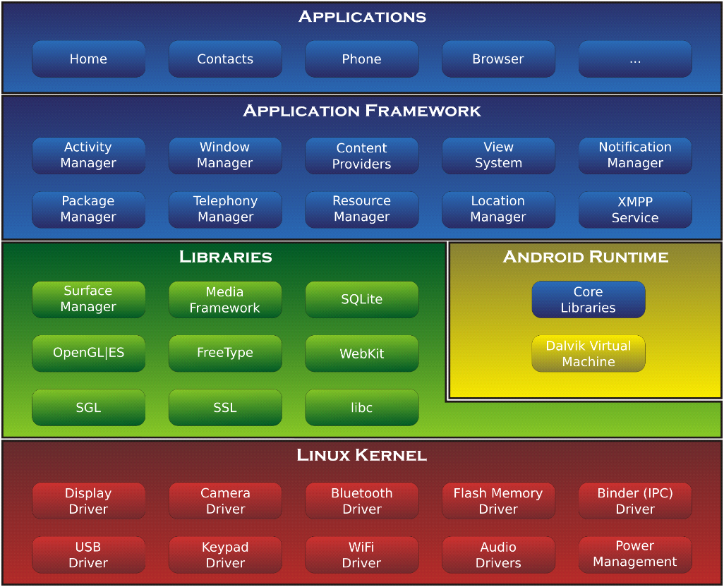

*Figure 1*

The pre-installed and 3rd party android applications are written in Java. The normal Java compiler foremost compiles the codes into Java byte code, which is then transformed into Dalvik byte code, dex files that runs in the Dalvik VM on any android device.

There are differences between normal Java and Dalvik byte code, but this is normally not an issue for a 3rd party developer. It is possible to run Java optimization frameworks such as Proguard, but sometimes this generates Java bytecode that cannot be converted to dex-bytecode. The Android SDK has different sets of APIs form the normal Java environment. The important parts of normal Java APIs are included, including java.nio, java.lang and java.util, but virtually all classes related to normal Java GUI code including AWT or SWING are removed. These are instead replaced with Android specific GUI and system classes. Google has chosen to not include J2ME, an older version of Java for mobile phones, and to only include a subset of the normal Java APIs in the Android SDK. Push Platform

18

The SDK also include Khronos OpenGL ES framework for 3D rendering, the Apache Harmony HTTP components and W3C XML parsing components

1.8 Firebase

Firebase is an open source backend platform for web, android and IOS applications. It offers real time database, different APIs, multiple authentication types and hosting platform. This is an introductory tutorial, which covers the basics of the Firebase platform and explains how to deal with its various components and sub-components.

1.8.1 Firebase Features

* Real-time Database − Firebase supports JSON data and all users connected to it receive live updates after every change.
* Authentication − We can use anonymous, password or different social authentications.
* Hosting − The applications can be deployed over secured connection to Firebase servers.

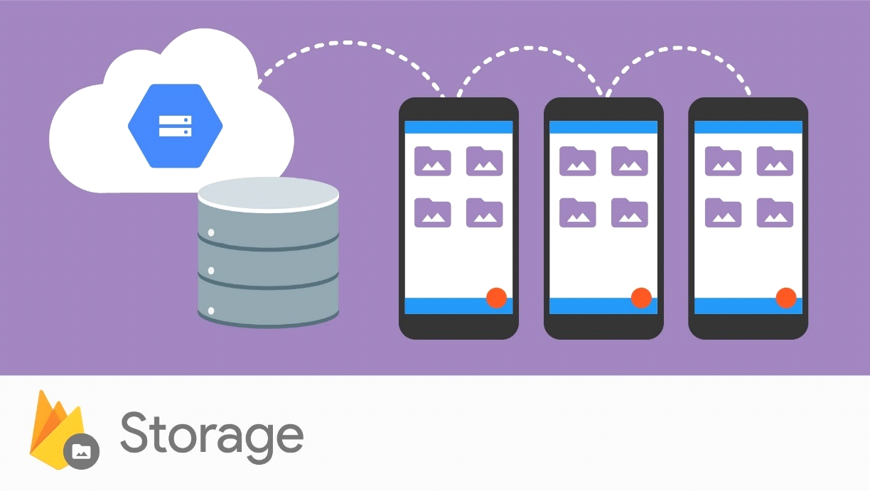

*Figure 2*

**Advantages of using Firebase**

* It is relatively easy and user friendly. That is its not a complicated system to master or configure.
* The data is in rea-time, which means users can monitor their work as soon as they modify it
* Firebase has many other services to choose from like authentication, storage and so on

**Limitations**

* The firebase free plan is limited to 50 connections and 100Mb of storage

Chapter 2: Feasibility

2.1 Feasibility

A feasibility study looks at the viability of an idea with an emphasis on identifying potential problems. It attempts to answer two main questions: Will the idea work, and should you proceed with it? To ascertain that conclusions, one must carry out the following studies

2.1.1 Technical Feasibility

A technical feasibility study is an excellent tool for troubleshooting and long-term planning. In some regards, it serves as a flow chart of how your products and services evolve and move through your business to physically reach your market.

Basing on the assumptions of a technical feasibility, I would like to state that software requirements are available that is to say I will be using:

* Java language that is readily available
* Android studio that is free to install
* Eclipse
* Smart Draw
* Firebase

and on the hardware department I will be using:

* Ram with 8Gb
* Disk of 500gb

CPU with a quad core processor

thus, I would like to confirm that the project is technically feasibility

2.1.2 Functional Feasibility

Operational Feasibility is the technically the study of Technical feasibility with an exception of assuming the environment and its constrains. The main obje ct of this study is to prove that farmers and consumers will be able to work fluently this application. All the information stored is confidential. It will enable smooth conversation between the two parties. With all this considered, I can agree with complete confidence that users will us the application efficiently.

2.1.3 Economic Feasibility

Economic feasibility study focusses on one particular project or area, or on a group of projects (such as advertising campaigns). This tests the financial possibilities and requirements of the project.

|  |  |  |
| --- | --- | --- |
| ITEM | QUANTITY | COST |
| Deployment on google store | 1 | 25$ |
| Hardware cost |  | None |
| Software cost |  | None |
| Labour cost |  | None |
| Total |  | 25$ |

*Table 1*

I can concur that generally the resources are attainable thus economically feasible.

Chapter 3: Project Planning

3.1 Project charter

The main aim of the project is to make relationship between consumers and farmers so as to enable easy accessibility of goods and in their region.

Major stake holders

* Consumers
* Admin

Estimated Time frame = 45 weeks

3.2 Client Functional Requirements

|  |  |  |  |
| --- | --- | --- | --- |
| No | Users | Functions | Done |
| 1 | **Consumer** | View list of crops name and quantity type |  |
| 2 |  | Register |  |
| 3 | Login |  |
| 4 | Remember me |  |
| 5 | Forgot password |  |
| 6 | Modify profile and password |  |
| 7 | View list of categories of crops |  |
| 8 | View list of crops within category |  |
| 9 | Search list of crops within category by name |  |
| 10 | View list of crops name |  |
| 11 | Search list of all crops by name |  |
| 12 | View crop description |  |
| 13 | Subscribe to crops |  |
| 14 | View list of crops subscribed to |  |
| 15 | Call client |  |
| 16 | Navigate to the location |  |
| 17 | Post crop details for sale that is quantity, price location and expiry date |  |
| 18 | Place the location to meet up |  |
| 19 | Update crop details in case like some quantity has been sold |  |
| 20 | Remove crop details |  |
| 21 | View map of crop concentration showing crop status |  |
| 22 | Send message to admin if crop does not exist |  |
| 23 | Get notification of new crop from subscribed to |  |
| 24 | Get notification from admin |  |
| 25 | Integrate Facebook |  |

*Table 2.1*

3.3 Admin functional requirements

|  |  |  |  |
| --- | --- | --- | --- |
| No | Users | Functions | Done |
|  | **Admin** |  |  |
| 1 | Login |  |
| 2 | Forgot password |  |
| 3 | Add category |  |
| 4 | Update category |  |
| 5 | Delete category |  |
| 6 | View categories |  |
| 7 | Add crop |  |
| 8 | Update crop |  |
| 9 | Delete crop |  |
| 10 | View crop description |  |
| 11 | View list of crops within category |  |
| 12 | Search crop within category by name |  |
| 13 | View list of all crops |  |
| 14 | View all clients |  |
| 15 | Search users by name |  |
| 16 | Freeze user |  |
| 17 | Change password |  |
| 18 | Mark message as read |  |
| 19 | View pending messages |  |
| 20 | View map of crops showing crops status |  |

*Table 2.2*

3.4 Methodology

Method is the guideline to be used to solve problems regarding how to do the project efficiently.

* **Adaptive project framework**

In this methodology, the project scope is a variable. Additionally, the time and the cost are constants for the project. Therefore, during the project execution, the project scope is adjusted in order to get the maximum business value from the project.

**Advantages of**

* **Agile software development**

This is a set of methods used by developers when planning a project where the solutions change with through collaborations between self-organizing, cross-sectional terms.

* **Scum**

It is an agile software development model based on multiple small teams working in an intense manner. It is obtained from the rugby game where players cover around the ball and try to push the opposing players off the ball.

* **Waterfall**

This is the legacy model for software development projects. This methodology has been in practice for decades before the new methodologies were introduced. In this model, development life cycle has fixed phases and linear timelines. This model is not capable of addressing the challenges in the modern software development domain.

After assessing all the methods, I decided to use the adaptive project framework method because I realised that my project would be predetermined, and the plans of the final assessment would change as the project went through hence producing a unique project. This method enables me to adjust the project as the final design manifests.

3.5 Gantt Chart

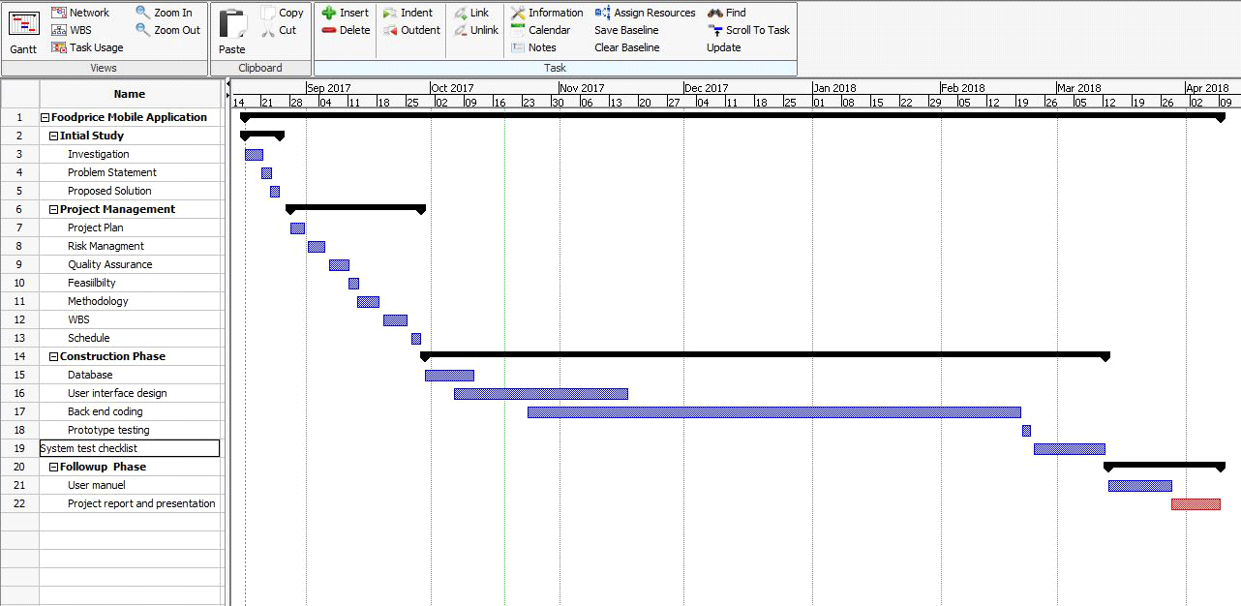

*Figure 3.1*

3.6 Food price mobile Application Schedule

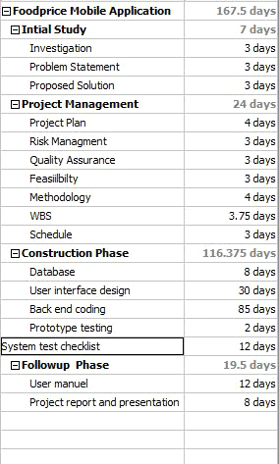

*Figure 3.2*

3.7 Work Breakdown Structure

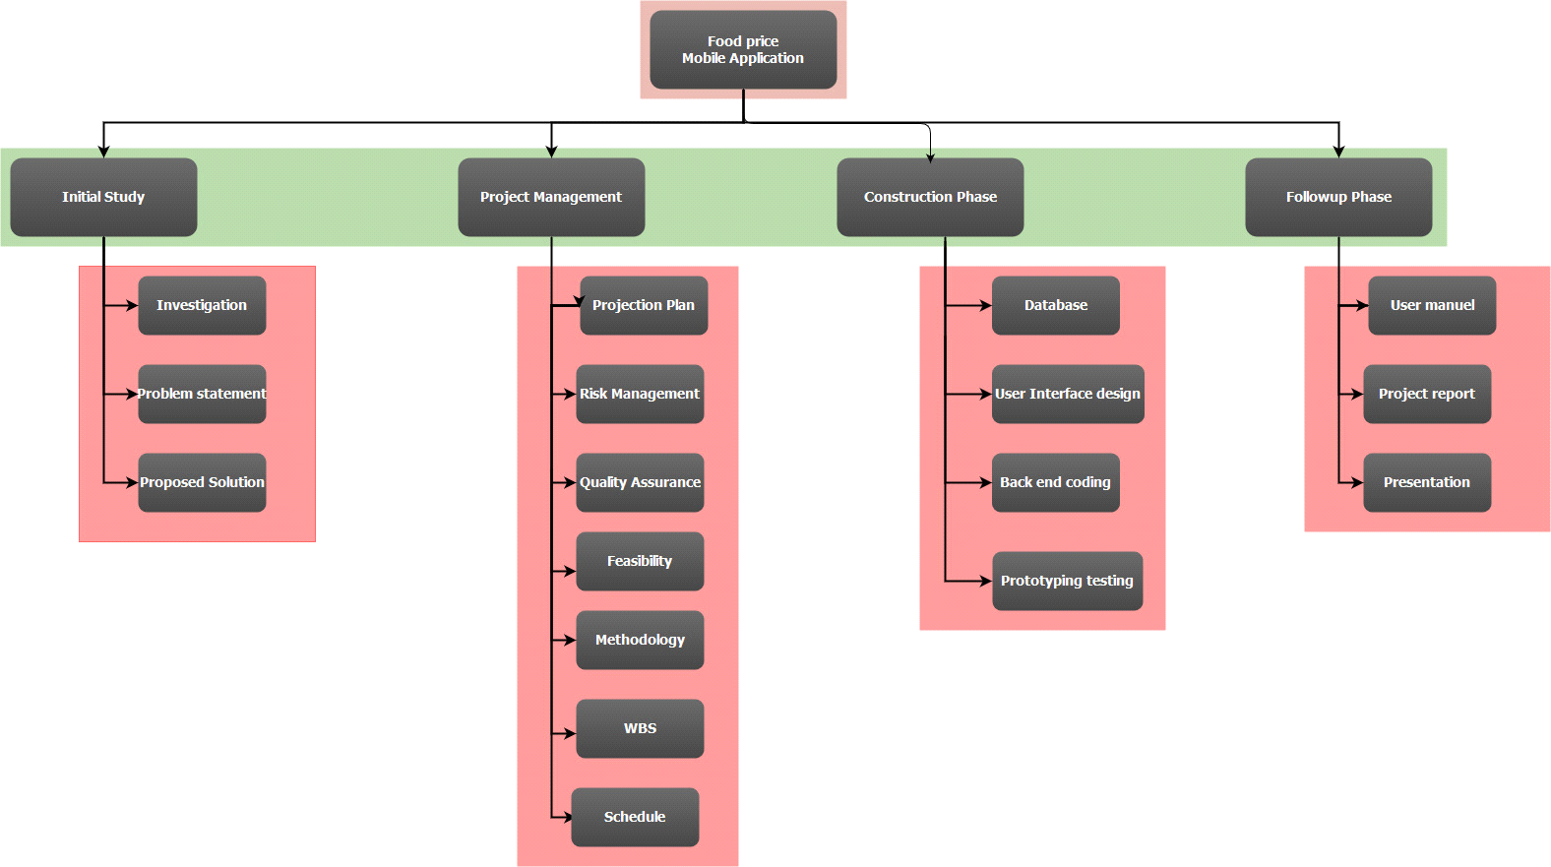

*Figure 4.1*

3.8 Risk Assessment

|  |  |  |  |  |
| --- | --- | --- | --- | --- |
|  | Risk | Possibility | Effect | Mitigation |
| 1 | Computer virus | low | serious | Installing and updating antivirus software |
| 2 | Safety | Low | Serious | Installing burglar proof locks |
| 3 | Technology advancements | Medium | Serious | Using the latest updates |
| 4 | Internet connection | Medium | Moderate | Buying mobile data to backup |
| 5 | Delays | Medium | Moderate | Constantly monitoring schedule |
| 6 | Financial restriction | Low | Moderate | Asking for external assistance |

*Table 3*

Chapter 4: Design of project

4.1 Knowledge from research and analysis

After the analysis and the research stage, I have learnt the different steps to do to be able to achieve a good efficient system. Note that the system will be in two parts, the web server and the client. Below are the tasks to be done in the design phase:

* Develop the structure of the software to be implemented
* Describe the system components
* Describe the algorithms to be used

Note that the quality of the design will have a direct impact on the implementation of the programming codes.

4.2 Brief overview of the project

The system will ne developed base on the architecture deign of the software requirement specifications. The system will consist of two separate applications client and admin. They will both be connected to the same firebase database. This will enable easy accessibility as I will demonstrate in the testing. We will also require a google map API to access the map from the google map services.

4.3 Database Dictionary

4.3.1. Clients

|  |  |  |  |  |
| --- | --- | --- | --- | --- |
| Column name | Datatype | Key | Description | Example |
| phonenumber | Number (10,0) | PK | Unique phone number of the user | 59836628 |
| username | Varchar (50) | No | The name the user will use | Tonny |
| password | Varchar (50) | No | The password of the user | H2u3huh |
| role | Varchar (50) | No | The role the user will login as, client and admin | Client |
| activationstatus | Varchar (50) | No | This is the status is see if the user is allowed or frozen | Active |
| activationcode | Varchar (50) | No | This the activation code for user on registration | 423gev32t3223 |

*Table 4.1*

4.3.2. Category

|  |  |  |  |  |
| --- | --- | --- | --- | --- |
| Column name | Datatype | Key | Description | Examples |
| Category_id | integer | PK | Unique identifier for the application |  |
| Category_name | Varchar (20) | NO | Name of the category of the crop | Legumes |
| image | blob | No | Image of the category for the crop |  |

*Table 4.2*

4.3.3. Crops

|  |  |  |  |  |
| --- | --- | --- | --- | --- |
| Column name | Datatype | Key | Description | Example |
| cropname_id | Int | PK | Unique id of the crop to which has been added | 12 |
| cropname | Varchar (50) | No | Name of the crop | Beans |
| image | Blob | No | Image of the crop |  |
| quantity_type | Varchar(50) | No | The type of metric system to measure the crop | Kilograms |
| duration | Number | No | Time it takes for the crop to expire | 23 |
| categoryname | Varchar(20) | FK | Category id to which this crop belongs | legumes |

*Table 4.3*

4.3.4. Favourites

|  |  |  |  |  |
| --- | --- | --- | --- | --- |
| Column name | Datatype | Key | Description | Example |
| phonenumber | Int | FK | Phone number of the client | 59836653 |
| crop_id | Int | FK | Id of the crop subscribed to | beans |
| Duration | Int | No | Duration it takes the crop to expire | 10 |

*Table 4.3*

4.3.5. Subscriptions

|  |  |  |  |  |
| --- | --- | --- | --- | --- |
| Column name | Datatype | Key | Description | Examples |
| Subscription_id | Int | PK | Unique id of the crop to which has been added | 12 |
| phonenumber | Number | FK | Phone number of the farmer who placed the crop for sale. | 5639242 |
| quantity | Varchar (60) | No | The amount of the crop the farmer must sell | 200 |
| price | Number(5,0) | No | Price the farmer wants to sell his crop | 2300 |
| expiration_date | Datetime | No |  | 23.09.2017 |
| Latitude | Decimal | No | The latitude location of the where the farmer wants to meet | 20.126178671 |
| Longitude | Decimal | No | The longitude location of the where the farmer wants to meet | 57.22378237 |
| Status | Varchar (20) | No | The status of the crop | Pending, sold |

*Table 4.4*

4.3.6 Message

|  |  |  |  |  |
| --- | --- | --- | --- | --- |
| Column name | Datatype | Key | Description | Examples |
| messageid | Int | PK | Unique id of the message being sent | 12 |
| Date_sent | datetime | No | Date the message was sent | 20.02.2018 |
| sendernumber | Int | No | Number of the client who sent the message | 578311121 |
| Title | Varchar (40) | No | The title of the message being sent | Add beans |
| body | Varchar (100) | No | The body of the message being sent | Please add beans |

*Table 4.5*

4.4 Entity Relationship diagram

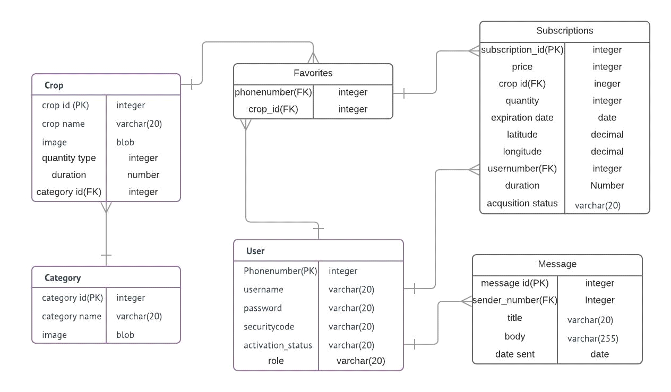

*Figure 5.1*

4.5 Use Case Diagram

4.5.1 Admin use-case diagram

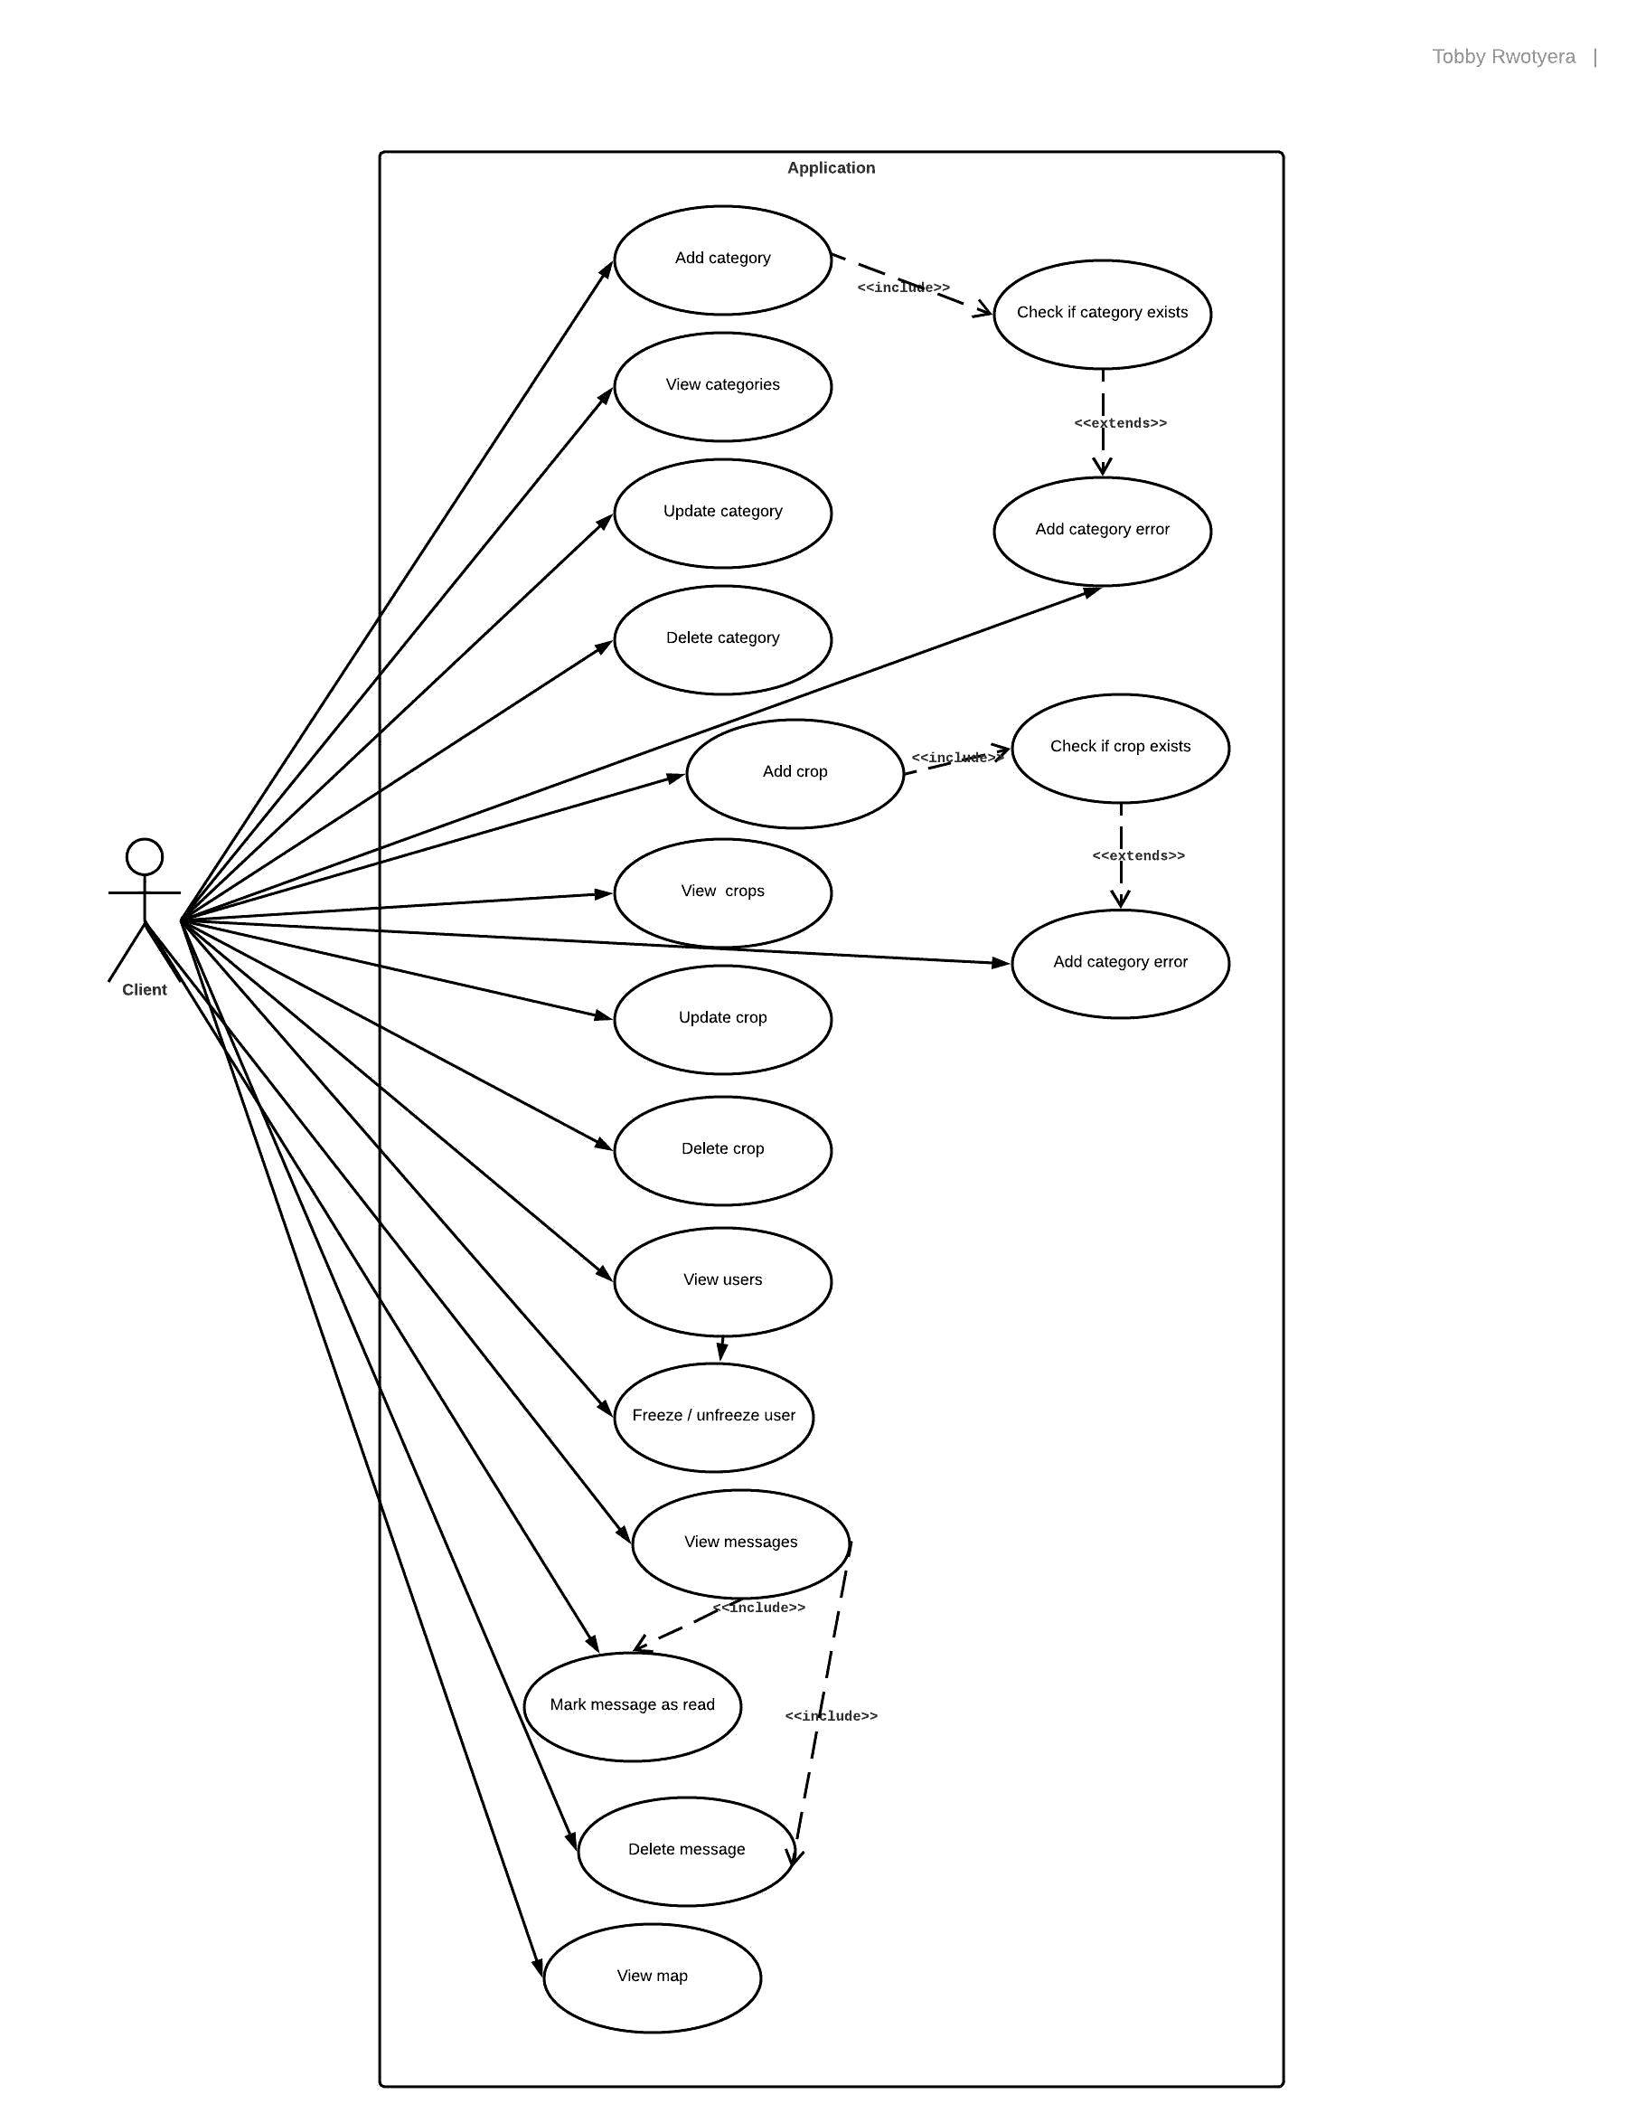

*Figure 6.1*

4.5.2 Client use-case diagram

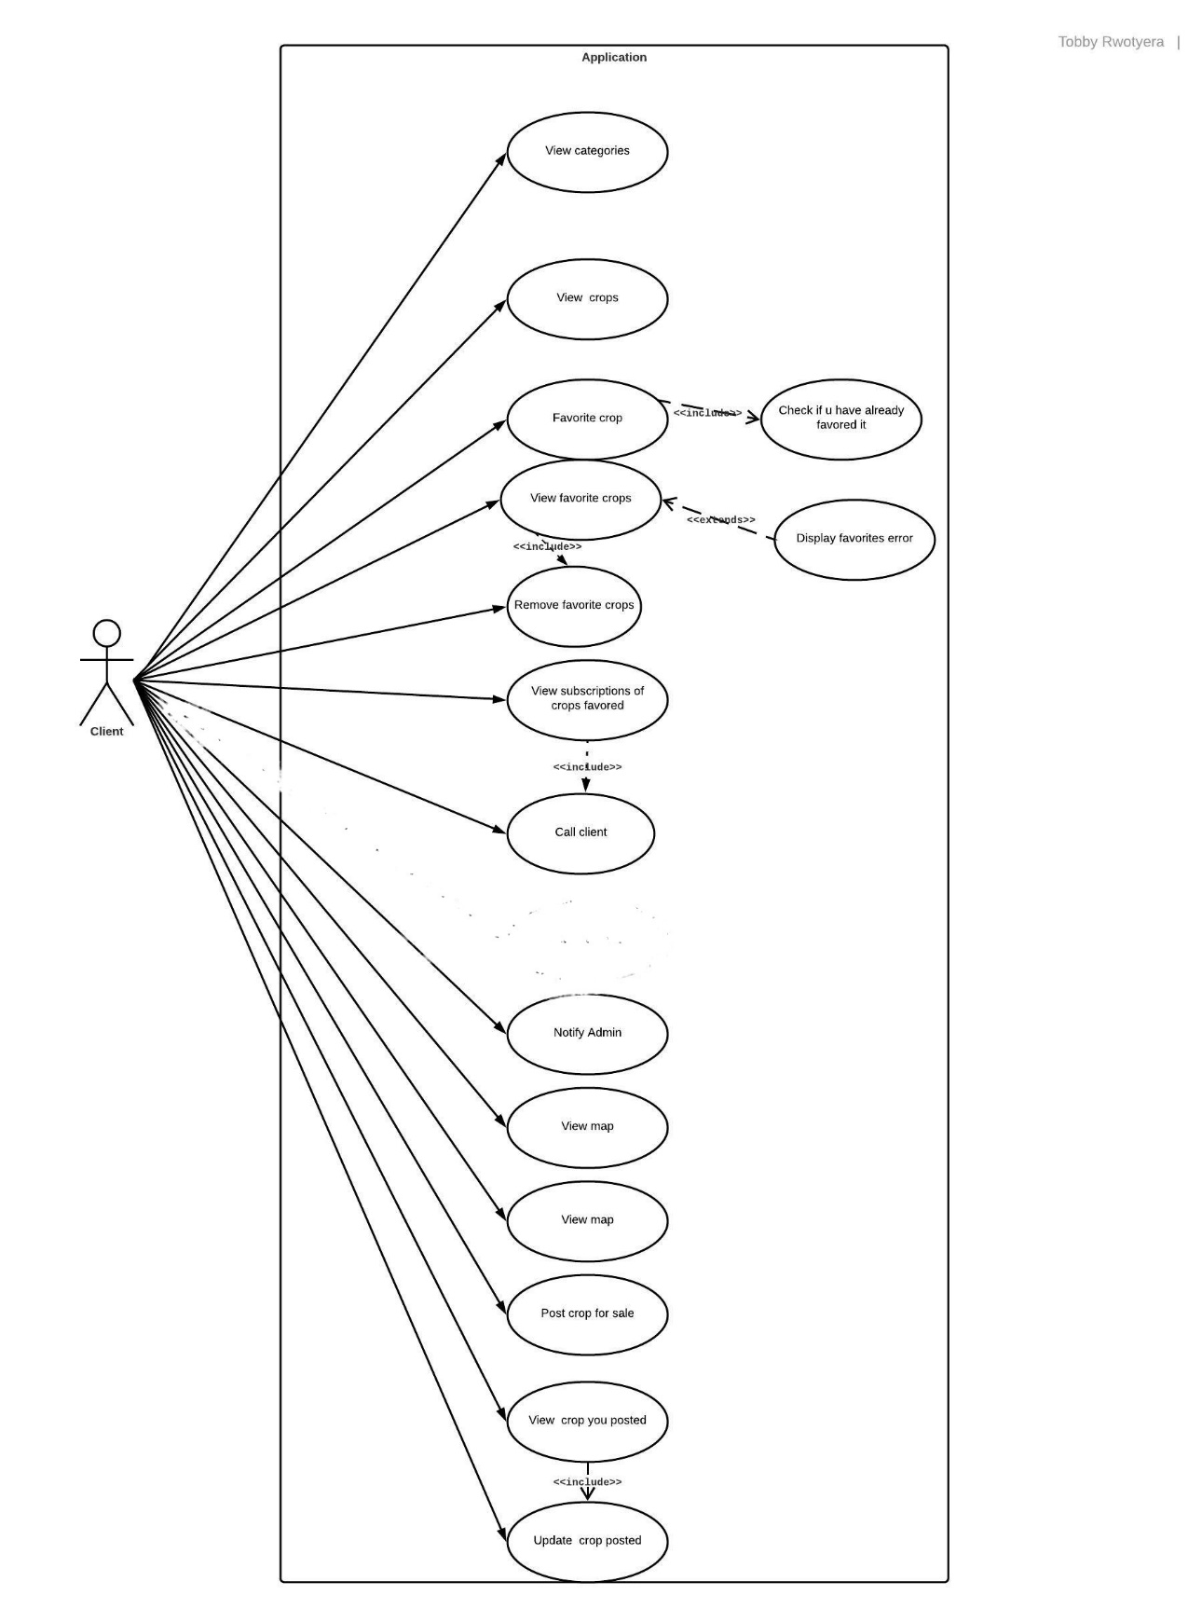

*Figure 6.2*

4.6 Description for use case

4.6.1 Registration

|  |  |
| --- | --- |
| **Use Case:** | Register new client |
| **Primary Actor:** | Client |
| **Pre-condition:** | User must not exist |
| **Flow of Event:** | * Enter user name * Enter user phone number * Enter user password |
| **System Requirements:** | User gets added to database |
| **Post-conditions:** | User can login to application |

*Table 5.1*

4.6.2 Favorite a crop

|  |  |
| --- | --- |
| **Use Case:** | Favorite to crop |
| **Primary Actor:** | Client |
| **Pre-condition:** | User must not be favorited to crop |
| **Flow of Event:** | * Click on shopping icon in crop details |
| **System Requirements:** | Crops get added to client’s favorites |
| **Post-conditions:** | User can get updates of the crop they favorited |

*Table 5.2*

4.6.3 Call the seller

|  |  |
| --- | --- |
| **Use Case:** | Call to client seller |
| **Primary Actor:** | Client |
| **Pre-condition:** | User must be favorited to crop |
| **Flow of Event:** | * Click on call icon |
| **System Requirements:** | User gets to communicate with the other client |
| **Post-conditions:** | User can either confirm transaction or not. |

*Table 5.3*

4.6.4 Navigate to seller’s location

|  |  |
| --- | --- |
| **Use Case:** | Navigate to client seller |
| **Primary Actor:** | Client |
| **Pre-condition:** | User must be favorited to crop |
| **Flow of Event:** | * Click on navigate button |
| **System Requirements:** | User gets to navigate to client |
| **Post-conditions:** | User can confirm transaction. |

*Table 5.4*

4.6.5 Post crop for sale

|  |  |
| --- | --- |
| **Use Case:** | Post crop for sale |
| **Primary Actor:** | Client |
| **Pre-condition:** | User must be favorited to crop |
| **Flow of Event:** | * Enter price * Enter quantity * Get location |
| **System Requirements:** | Crops gets added to subscriptions |
| **Post-conditions:** | User can call to buy your goods |

*Table 5.5*

4.6.6 Update crop posted on sale

|  |  |
| --- | --- |
| **Use Case:** | Update crop on sale |
| **Primary Actor:** | Client |
| **Pre-condition:** | User must be posted the crop |
| **Flow of Event:** | * Update price * Update quantity * Update location |
| **System Requirements:** | Crops gets updated to subscriptions |
| **Post-conditions:** | User can call to buy your goods |

*Table 5.6*

4.6.7 Confirm crop sold

|  |  |
| --- | --- |
| **Use Case:** | Confirm sale of crop |
| **Primary Actor:** | Client |
| **Pre-condition:** | User must be posted the crop |
| **Flow of Event:** | * Update sold status |
| **System Requirements:** | Crops status turns to sold in subscriptions table |
| **Post-conditions:** | User enjoys the sale of his goods |

*Table 5.7*

4.6.8 Change password

|  |  |
| --- | --- |
| **Use Case:** | Change password |
| **Primary Actor:** | Administrator and Client |
| **Pre-condition:** | User must exist |
| **Flow of Event:** | * Enter old password * Enter new password * Confirm new password |
| **System Requirements:** | User password get updated |
| **Post-conditions:** | User can login with new password |

*Table 5.9*

4.6.9 Add category

|  |  |
| --- | --- |
| **Use Case:** | Add category |
| **Primary Actor:** | Administrator |
| **Pre-condition:** | Category should not exist |
| **Flow of Event:** | * Enter category name * Select an image |
| **System Requirements:** | Category added to database |
| **Post-conditions:** | New category appears in category list |

*Table 5.10*

4.6.10 Update category

|  |  |
| --- | --- |
| **Use Case:** | Update category |
| **Primary Actor:** | Administrator |
| **Pre-condition:** | Category should exist |
| **Flow of Event:** | * Update category name * Update an image |
| **System Requirements:** | Category updated to database |
| **Post-conditions:** | Updated category appears in category list |

*Table 5.11*

4.6.11 Add crop

|  |  |
| --- | --- |
| **Use Case:** | Add crop |
| **Primary Actor:** | Administrator |
| **Pre-condition:** | Crop should not exist |
| **Flow of Event:** | * Enter category name * Select an image * Enter the duration of crop till expiration |
| **System Requirements:** | Crop updated to database |
| **Post-conditions:** | Crop added to crop list |

*Table 5.13*

4.6.12 Update crop

|  |  |
| --- | --- |
| **Use Case:** | Update crop |
| **Primary Actor:** | Administrator |
| **Pre-condition:** | Crop should exist |
| **Flow of Event:** | * Update category name * Update an image * Update the duration of crop till expiration |
| **System Requirements:** | Crop updated to database |
| **Post-conditions:** | Updated crop appears on crop list |

*Table 5.14*

4.6.13 Delete crop

|  |  |
| --- | --- |
| **Use Case:** | Delete crop |
| **Primary Actor:** | Administrator |
| **Pre-condition:** | Crop should exist |
| **Flow of Event:** | * Delete crop |
| **System Requirements:** | Table crop updated to database |
| **Post-conditions:** | Updated crop does not appear on crop list |

*Table 5.15*

4.6.14 Freeze user

|  |  |
| --- | --- |
| **Use Case:** | Freeze/ unfreeze user |
| **Primary Actor:** | Administrator |
| **Pre-condition:** | User should exist |
| **Flow of Event:** | * Freeze / unfreeze user |
| **System Requirements:** | Table user updated to database |
| **Post-conditions:** | User either gets blocked out if frozen or allowed back in if unfrozen |

*Table 5.16*

4.6.15 Mark message as read

|  |  |
| --- | --- |
| **Use Case:** | Mark message as read |
| **Primary Actor:** | Administrator |
| **Pre-condition:** | Message should exist  Message should bold |
| **Flow of Event:** | * Click in the seen icon |
| **System Requirements:** | Message status gets updated |
| **Post-conditions:** | Message is no longer bold and marked as read |

*Table 5.17*

4.6.16 Delete message

|  |  |
| --- | --- |
| **Use Case:** | Delete message |
| **Primary Actor:** | Administrator |
| **Pre-condition:** | Message should exist |
| **Flow of Event:** | * Click in the delete icon |
| **System Requirements:** | Table messages get updated |
| **Post-conditions:** | Message gets deleted from database |

*Table 5.18*

4.7 Flow chart Diagram

4.7.1 Registration Flow chart

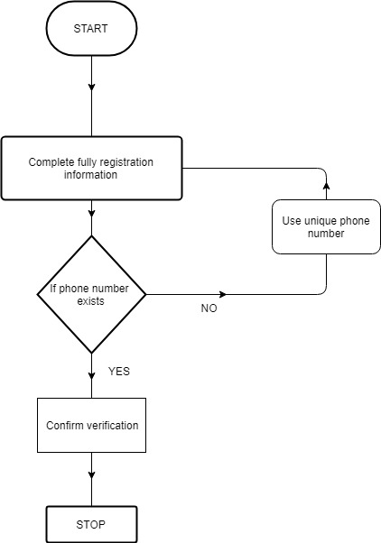

*Figure 7.1*

4.7.2 Demonstration of how to favourite a crop

**w**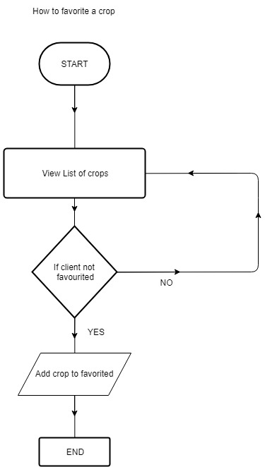

*Figure 7.2*

4.8 State Diagram

Representation of acquisition of crop

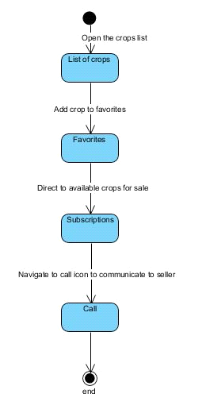

*Figure 7.3*

4.9 Interface Design

This interface design will briefly explain the different designs that will appear in the application

4.9.1 Admin home page

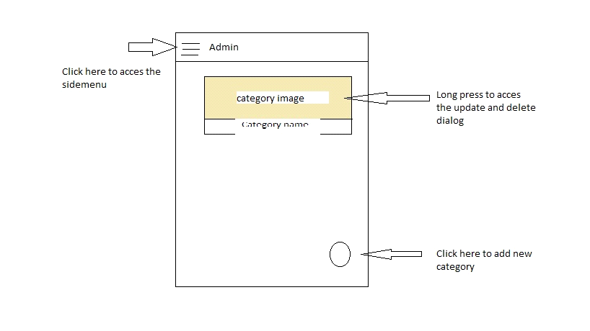

*Figure 8.1*

4.9.2 Admin crop page

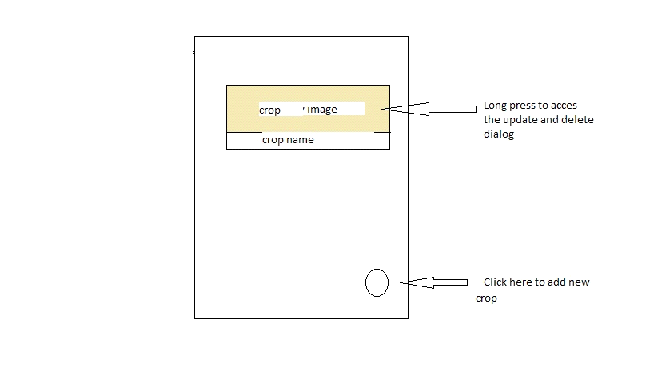

*Figure 8.2*

4.9.3 The client home page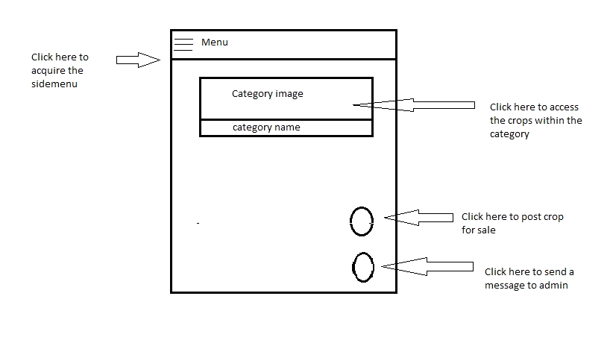

*Figure 8.3*

Chapter 5: Quality Management

5.1 Quality management

Quality management is the act of overseeing all activities and tasks needed to maintain a desired level of excellence. This includes the determination of a quality policy, creating and implementing quality planning and assurance, and quality control and quality improvement. It is also referred to as total quality management (TQM).

5.3 Quality Planning

This can be clearly defined in the overview of the project. It enables all members of the project to understand what type of standard the application is to achieve.

Generally, this project quality plan is to limit the risk of developing a substandard project. The quality design to achieve is to be followed to a T.

To ensure the system which is being developed is of quality and meets standards, a particular set of standards as mentioned below

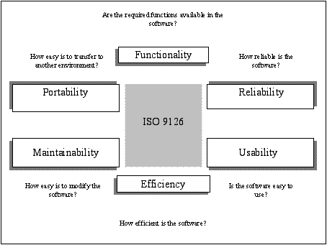

*Figure 8.4*

Chapter 6: Implementation

6.1 Software Validation

In order for the application to be effective I placed some validations to avoid some common mistakes

6.1.4 Add image

The application will generate an id and store image in firebase

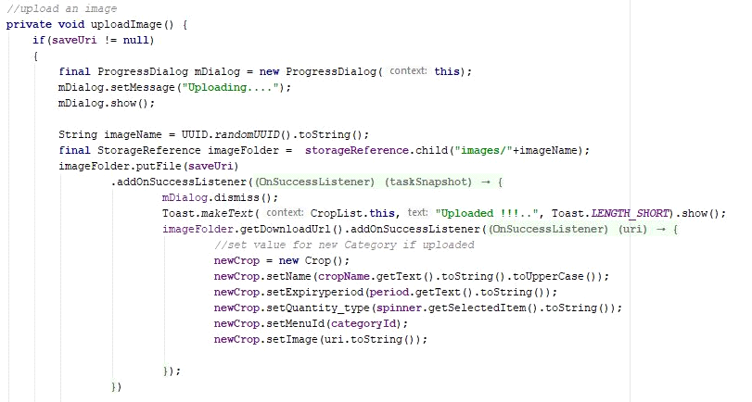

*Figure 11.3*

6.1.5 Display

The application will display information in a recycler using this method

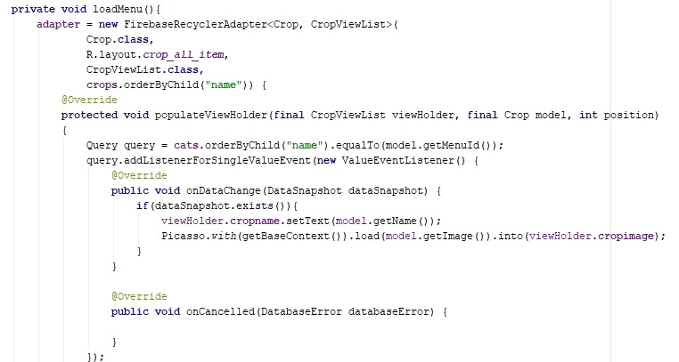

*Figure 11.4*

6.1.7 Delete message

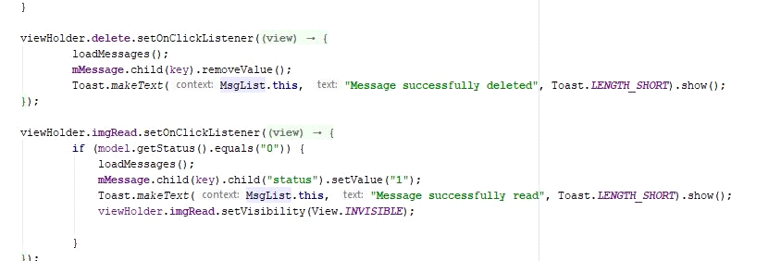

*Figure 11.6*

6.1.8 Freeze client

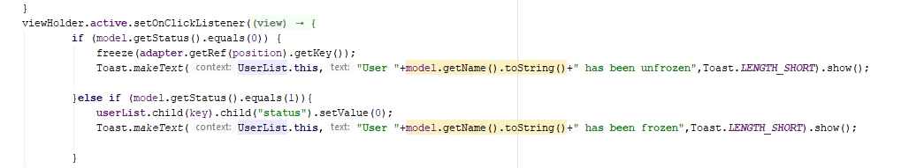 *Figure 11.7*

6.2 Software Verification

6.2.1 Registration

The application checks if the user exists, and if there are null values

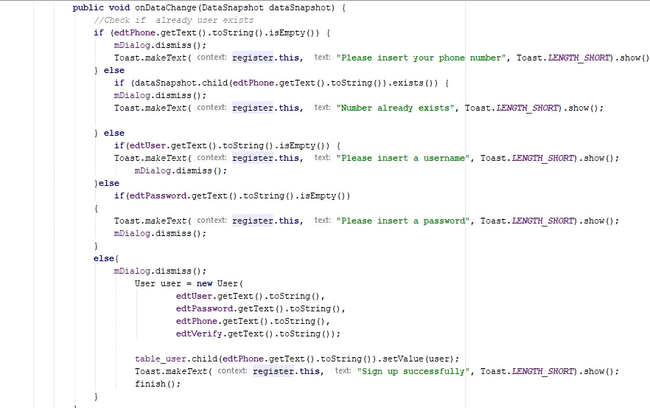

*Figure 11.1*

6.2.2 Login

The application will check if user does exist

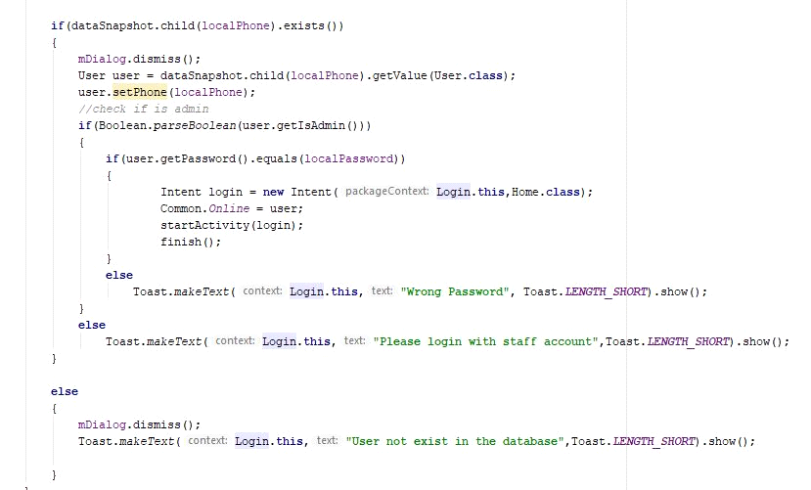

*Figure 11.2*

Chapter 7: Testing

7.1 Testing Client

7.1.1 Registration Testing

**Aim:** To register as a client

**Procedure:** The client fills in his phone number, name and preferred password as demonstrated below

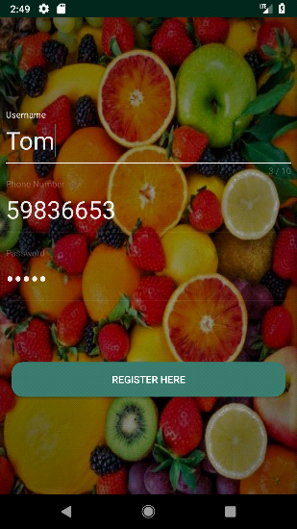 *Figure 9.1*

**Result:** The client successfully regists as a new user and when wrong an error message appears

**Status:** pass

7.1.2 Login

**Aim:** To allow the client login his phone number and password

**Procedure:** Enter the users details and check if user and password exist

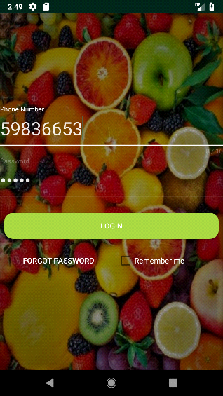 *Figure 9.2*

**Result:** The correct information was inserted and it logins in and when wrong an error message appears

7.1.3 Home page

**Aim:** To view the home page

**Procedure:** Login

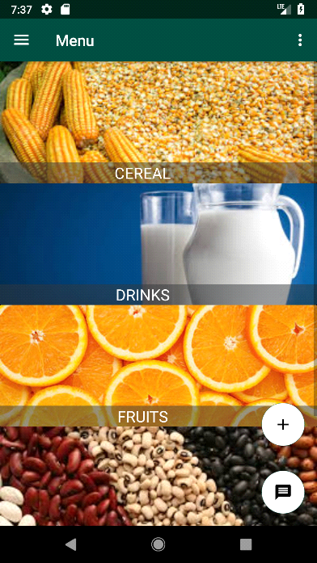 *Figure 9.3*

**Result:** Successfully view main home page for client

7.1.4 Menu

**Aim:** View the menu list for client

**Procedure:** Click on the top left bar to view the side menu

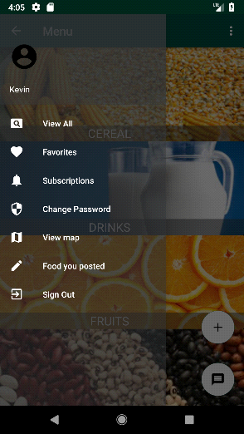 *Figure 9.4*

**Result:** Successfully displays the menu for client

7.1.6 View list of crops

**Aim:** View a list of crops within a category

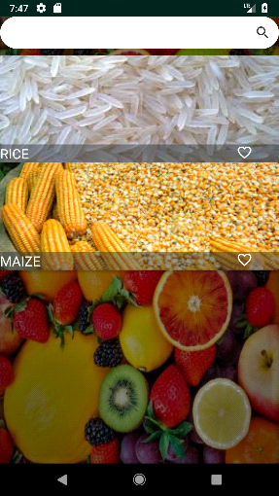*Figure 9.5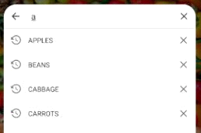 Figure 9.6*

**Procedure:** Click on a category and search by a name

**Result:** Displays the list of crops

7.1.7 View crop details

**Aim:** To view more about the crop

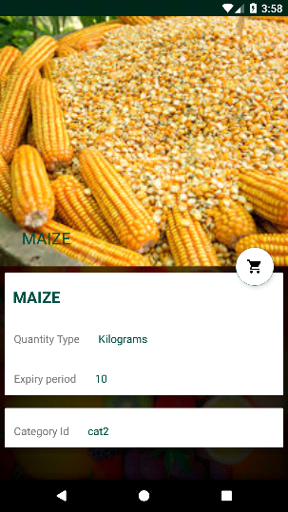 *Figure 9.7*

**Procedure:** Click on the crop

**Result:** Display crop name, image and gestation period of the crop

7.1.8 Favourite a crop

**Aim:** To add crop to favourites

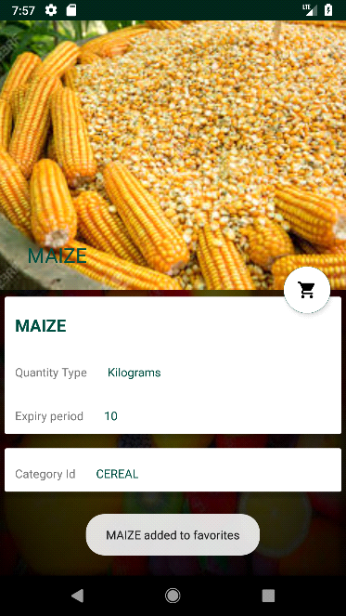*Figure 9.8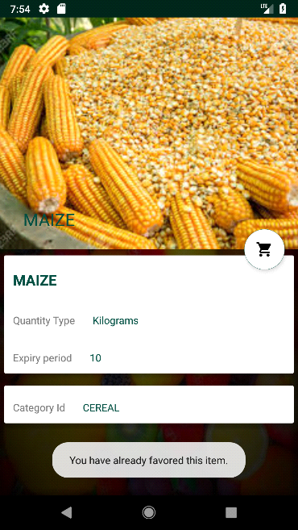 Figure 9.9*

**Procedure:** Click on the shopping icon in the details

**Result:** Crop successfully added to favourites and an error if you had already added it

7.1.9 View list of favourited crops

**Aim:** To view a list of all the crops I have favourited

**Procedure:** Go to the side menu and click on favourites

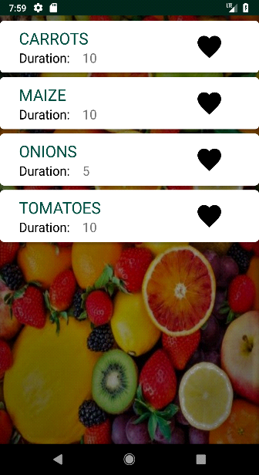 *Figure 9.10*

**Result:** Display list of crops you favourited and their gestation period

7.1.10 Remove crop from favourites

**Aim:** To remove a crop from my list of favourites

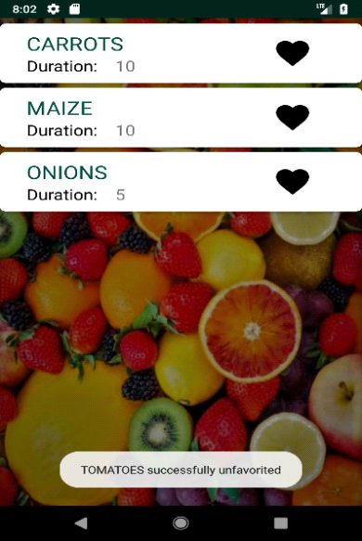

*Figure 9.11*

**Procedure:** Click on the favourite icon

**Result:** Crops successfully eliminated

7.1.11 View list of crops on sale

**Aim:** To view the list of crops on sale

**Procedure:** Click on the subscriptions in the side menu from the main page

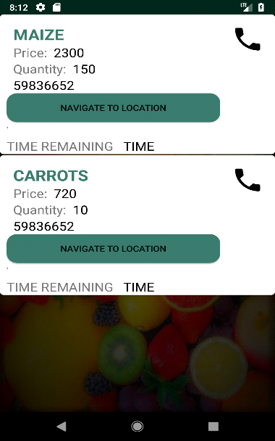 *Figure 9.12*

**Result:** Displays a name, price, quantity, seller and the call icon

7.1.12 Call the potential buyer

**Aim:** To call the potential buyer

**Procedure:** Click the call icon in subscriptions

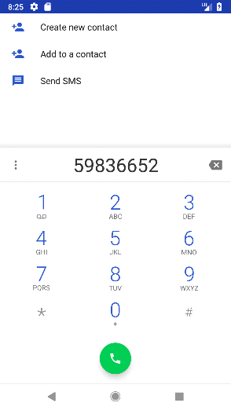 *Figure 9.13*

**Result:** Communicate with seller

7.1.13 Go to location

**Aim:** To go to the location of the client

**Procedure:** Click the call icon in subscriptions

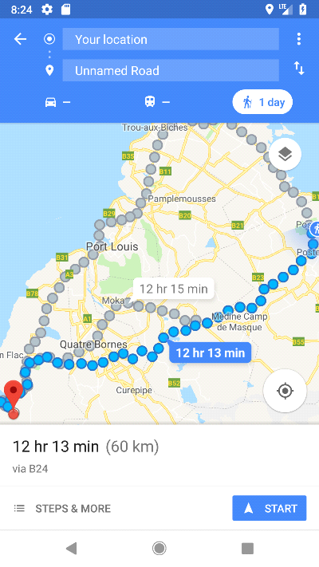 *Figure 9.14*

**Result:** Communicate with seller

7.1.14 Post a crop for sale

**Aim:** To post a crop for sale

**Procedure:** Click on the post icon on the home page andenter the required information clearly

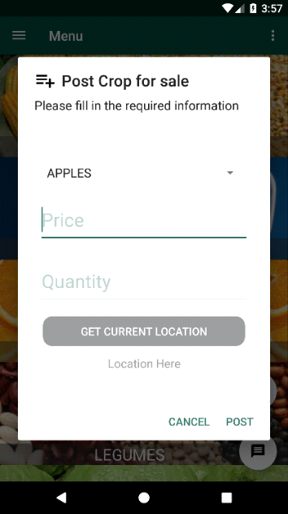 *Figure 9.15 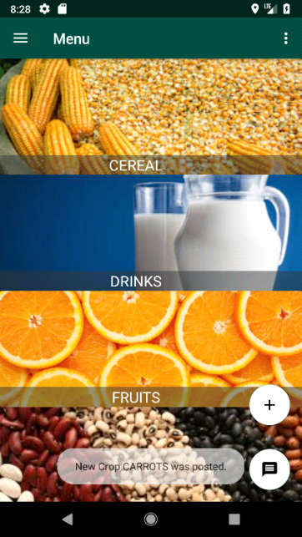 Figure 9.16*

**Result:** Crops successfully posted for sale if validation was successfully

7.1.1 5 View crops for sale

**Aim:** To View crops for sale

**Procedure:** Click on the post food from the side menu on home page

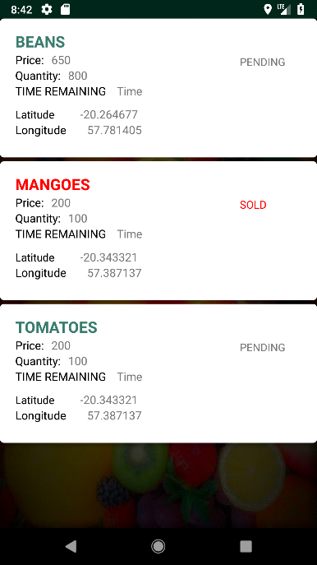 *Figure 9.17*

**Result:** Display all the crops you have placed for sale

7.1.16 Update crop posted for sale

**Aim:** To update crop posted for sale

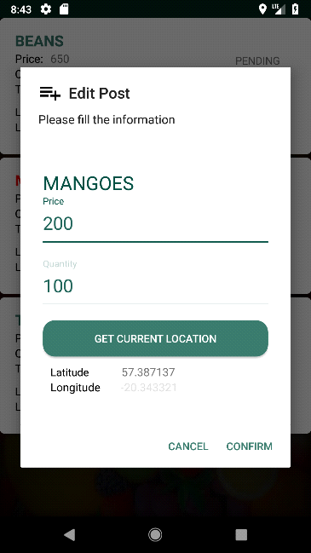 *Figure 9.18*

**Procedure:** Long click on the crop and select update. Then update the part you want to update and confirm

7.1.17 Confirm crop posted for sold

**Aim:** To Confirm crop posted for sold

**Procedure:** Long click on the crop and select sold.

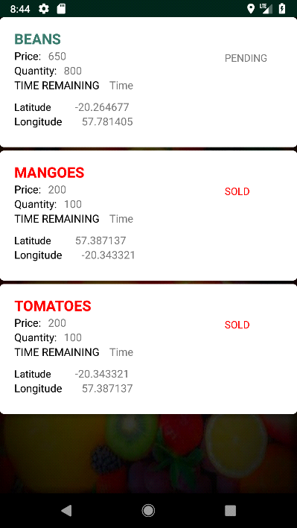 *Figure 9.19*

7.1.18 Message admin

**Aim:** To Send a message to admin

**Procedure:** Click on the message icon on the home page.

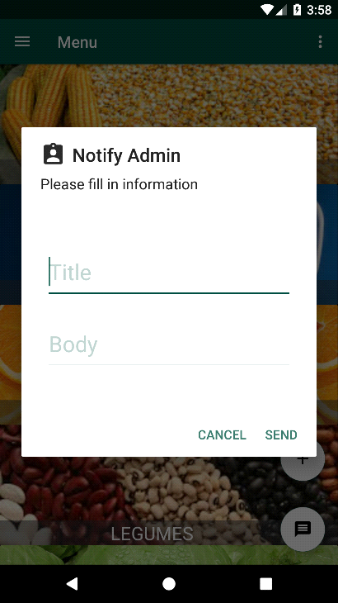 *Figure 9.20 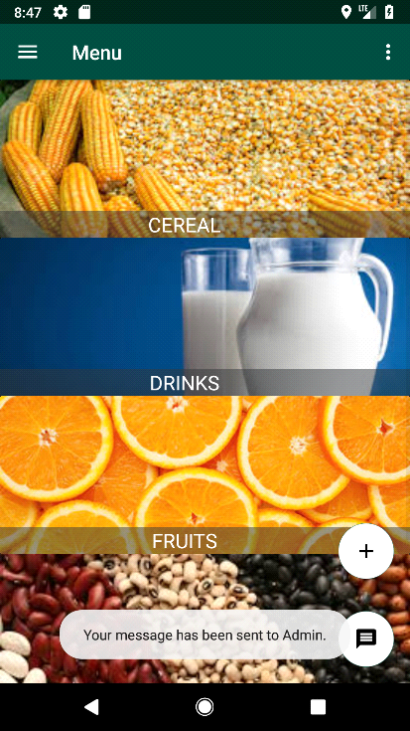 Figure 9.21*

7.1.19 Change password

**Aim:** To Change the user password

**Procedure:** Click on the change password on side menu and complete the information

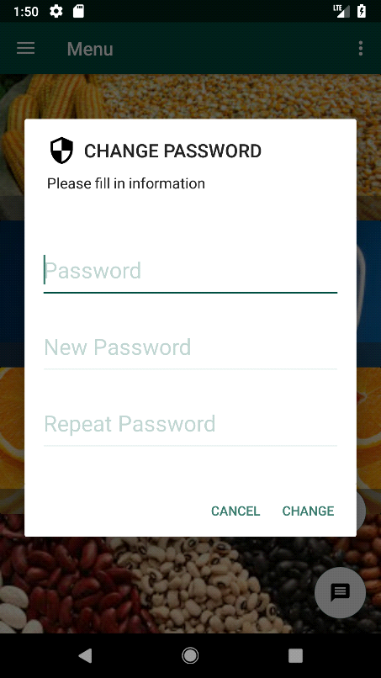 *Figure 9.22*

7.1.20 View map

**Aim:** To view the map with crops information

**Procedure:** Click on the map on side menu and complete the information

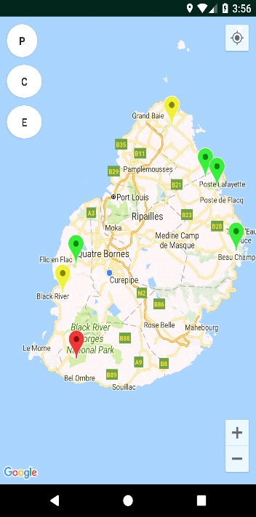 *Figure 9.23 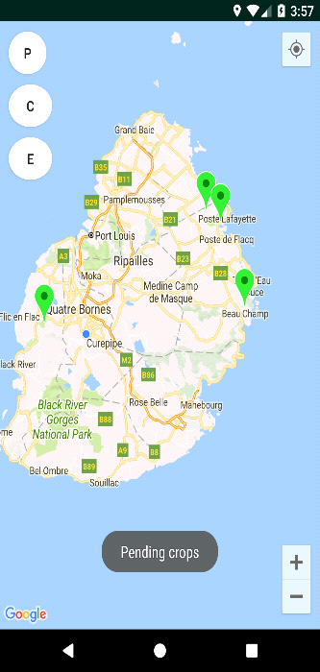 Figure 9.24 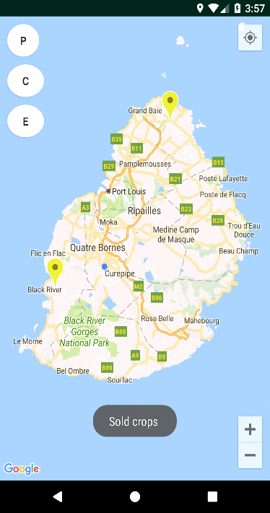 Figure 9.25*

7.2 Admin Testing

7.2.1 Admin home

**Aim:** To view the admin home page

**Procedure:** Login as admin

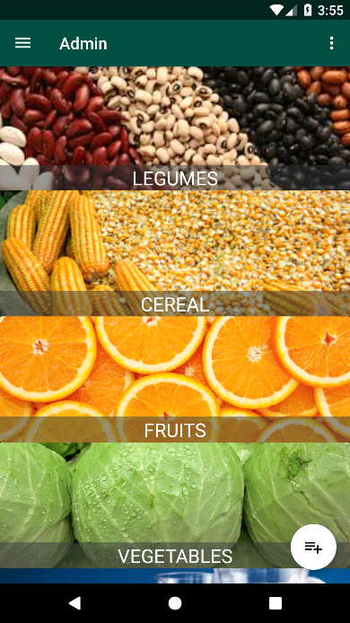 *Figure 10.1*

7.2.2 Admin Menu

**Aim:** To view the admin home menu

**Procedure:** Click the side menu icon

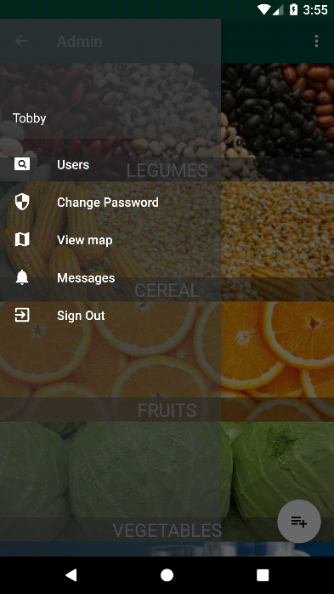 *Figure 10.2*

7.2.3 Add category

**Aim:** To add a category to the list

**Procedure:** Click on the add icon on the main page

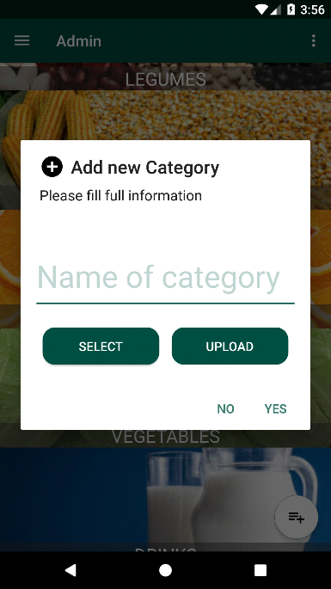 *Figure 10.3*

7.2.4 Update Category

**Aim:** To update the category

**Procedure:** Long press on the category and select update

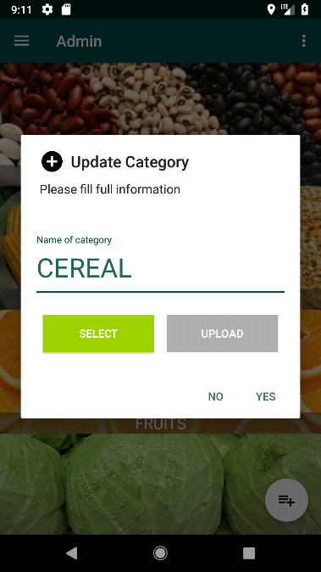 *Figure 10.4*

7.2.5 Delete category

**Aim:** To view the map with crops information

**Procedure:** Long press on the category and select delete

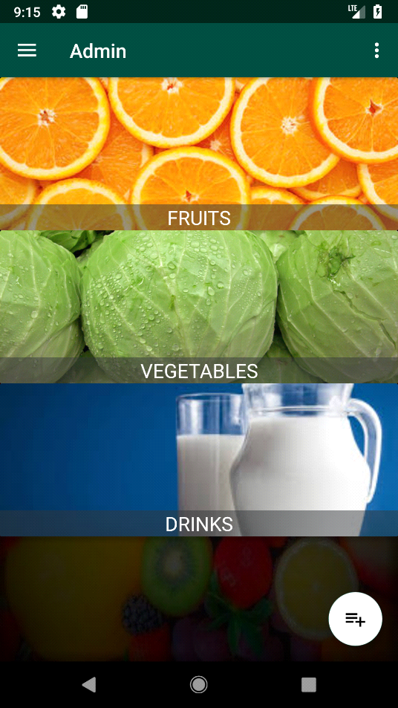 *Figure 10.5*

7.2.6 Add crop

**Aim:** To add a new crop

**Procedure:** Click on the add icon within the category

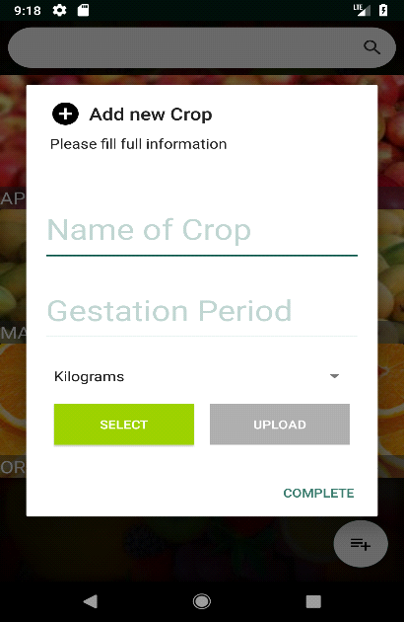 *Figure 10.6*

7.2.7 Update crop

**Aim:** To update information about the crop

**Procedure:** Long press the crop and select update

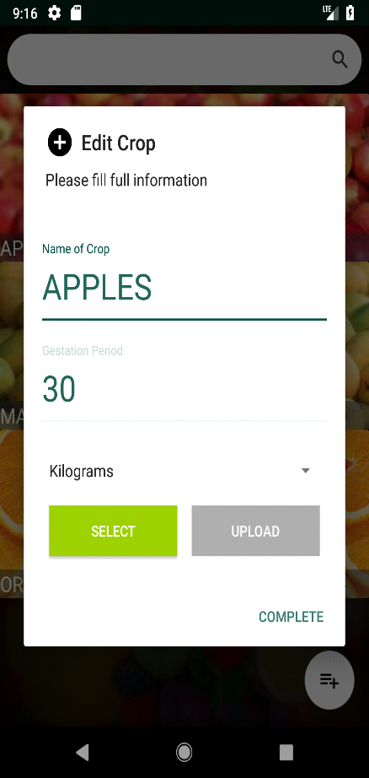 *Figure 10.7*

7.2.8 Delete crop

**Aim:** To delete the crop

**Procedure:** Long press on the crop and select delete

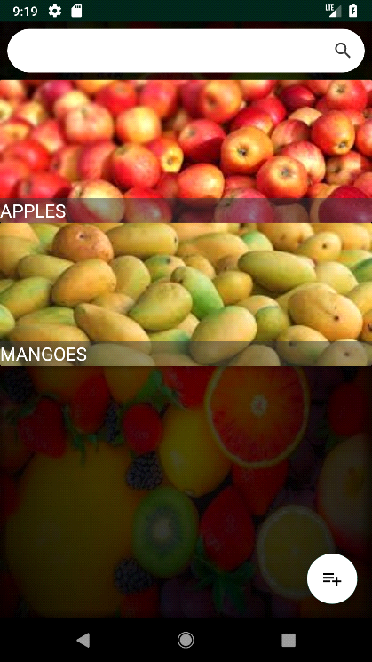 *Figure 10.8*

7.2.9 View messages

**Aim:** To view all the messages send to admin

**Procedure:** Click on the message on the side menu

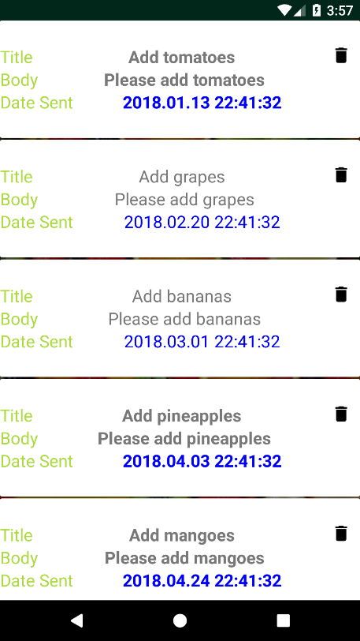 *Figure 10.9*

7.2.10 Mark message as read

**Aim:** To mark the message as read

**Procedure:** Click the seen icon on the message

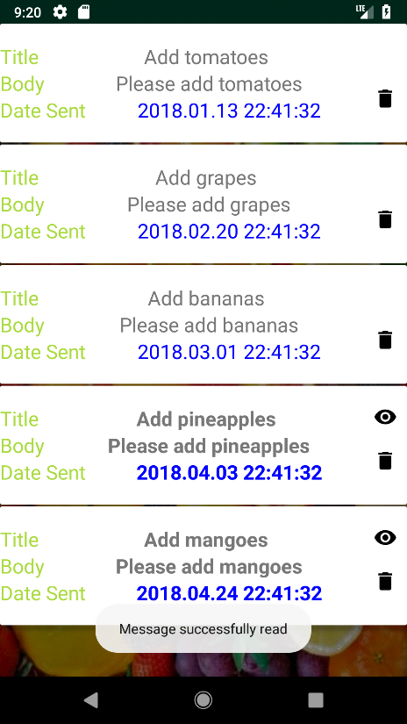 *Figure 10.10*

7.2.11 Delete message

**Aim:** To delete a message

**Procedure:** Click on the delete icon on the message

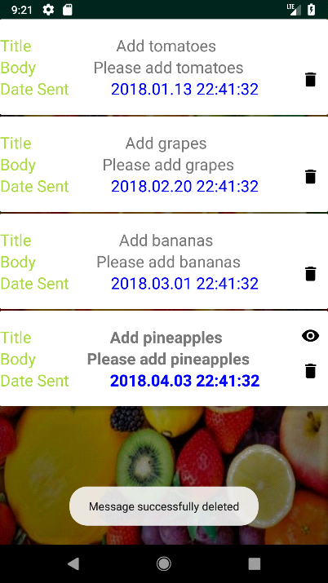 *Figure 10.11*

7.2.12 View users

**Aim:** To view all the users

**Procedure:** Click on the users in the from the sidemenu

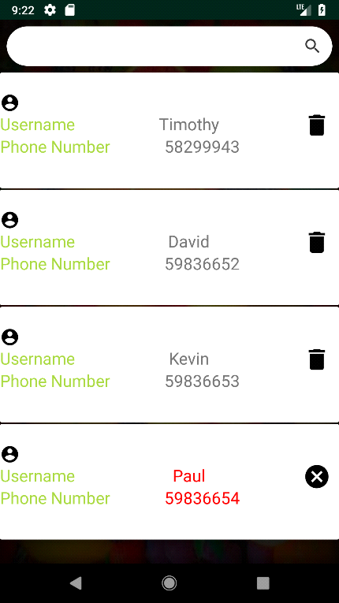 *Figure 10.13*

7.2.13 Freeze user

**Aim:** To block a user from accessing their account.

**Procedure:** Click on user icon delete

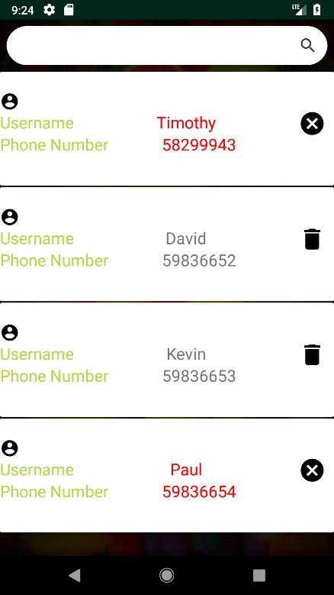 *Figure10.14*